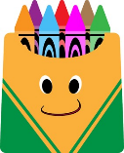 Ms. Michele Burt’s Pre-K VE Blended 3-4 old’s 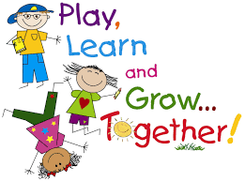
Supply List 2023-2024
*(1) poly/vinyl type folder (2 or 4 pockets)
*(1) backpack (no wheels) large enough for folder/class projects/ rest items
*(1) Crayola fat markers - 8 pack or more
*(2-3) containers of Play-Doh
* (1) liquid glue
*(1) large/fat glue sticks
*(1) large package of dry-erase-colored markers or (2) small packages
*(1) package of white copy paper and (1) package any color or multi-color paper or card stock

*(1) blanket and towel for rest time (no rest pillows and if possible, children’s sized blankets)
* A complete change of clothes (underwear, socks, pants & shirt), labeled with your child s name and in a Ziploc bag
*(5) plain white t-shirts (make sure you buy them big enough, so they’ll fit as they grow throughout the year)
*Snack items to share with the class (14+ students) as needed, (goldfish, pretzels, fruit snacks, Cheez-
its, Teddy Grahams, graham crackers, vanilla wafers, etc.)
*(2) boxes of Dixie type cups, 3oz or 5oz

*(2-3) liquid soaps or (1) refill liquid soap
*(2-3) boxes of Kleenex/tissues
*(2) containers of disinfecting wipes
*(1) containers of baby wipes or refill bags
*(4) Magic Erasers (generic is fine)
*(2) rolls of paper towels
* Boys (1) box of easy slide quart size and snack size Ziploc type bags / Girls (1) box of easy slide gallon size and sandwich size Ziploc type bags
* Stickers for earning a trip to the treasure box. Small stickers if possible.

**Optional items to donate: *Glitter-any color *Sticky back foam pieces *Large washable stamp pads *Small buttons *Craft materials *New-Old happy meal type toys for the treasure box

**Velcro Sided pull-ups and a box of baby wipes are to be supplied as needed if your child is not potty trained*

*Please label all personal items with your child's name.

